CREATIVE TASK

HTTP Security Header Analysis Using Curl
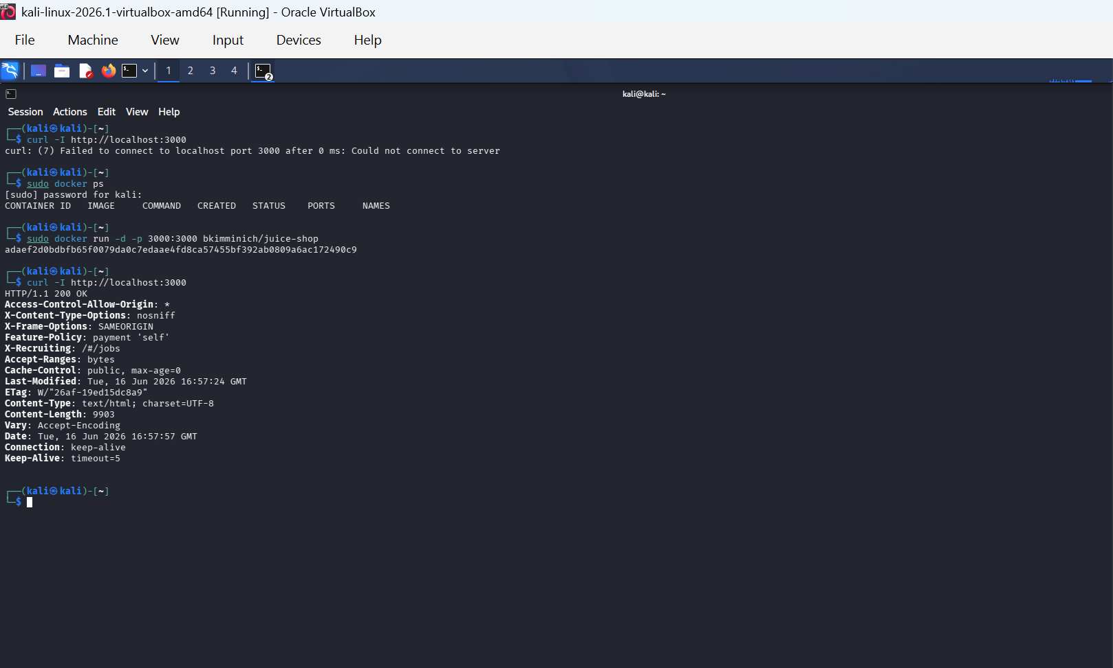

Explanation:
This screenshot shows the output of the curl -I http://localhost:3000 command executed in Kali Linux. It displays the HTTP response headers returned by the web application, which are used to analyze security configurations such as Content-Security-Policy, X-Frame-Options, and other protective headers.

